ASDS 6303
Roshan Adhikari
Project1

K-means clustering for unlabeled data

Objective:
To implement optimal k-means clustering on the Iris dataset to identify natural groupings of plants based on their sepal and petal measurements.

Dataset overview:
A brief sample of the dataset is shown below:
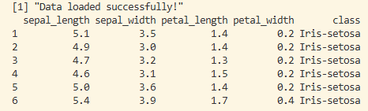
Where,
Features (Measurements in cm):
- Sepal: The outer, drooping part of the flower (the "falls").
- Sepal Length: Length of the sepal.
- Sepal Width: Maximum width of the sepal.
- Petal: The inner, upright part of the flower (the "standards").
- Petal Length: Length of the petal.
- Petal Width: Maximum width of the petal.
- Target Classes: 3 species (Setosa, Versicolour, Virginica) – For the purpose of clustering unlabeled data, we will be omitting this information for clustering but will use for evaluation.

Methodology:
-Data Validation: Automated checks for missing values (NA) and non-numeric features.
- Exploratory Analysis: Elbow Method to determine the optimal number of clusters (k).
-Algorithm: K-means Clustering (Interactive k, default=3)
-Preprocessing: Feature selection (numeric attributes only).
-Evaluation: Visualization and comparison with actual species labels.

Findings:
After running the k-means clustering elbow method, we obtained the following graph that shows the optimal k-means.
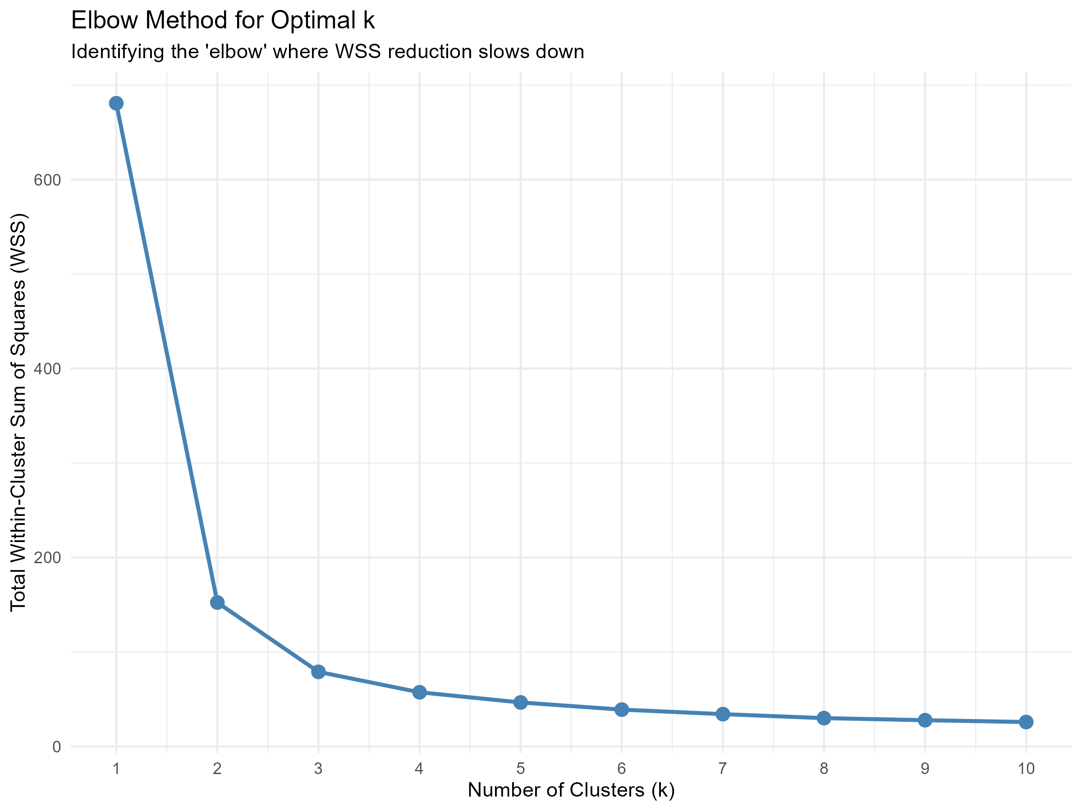
After k=3, the improvement in the WSS is minimal, which is why we will use k=3 to obtain the clustered plot. A user can enter any k in the R-console to obtain their choice of clustered plot.
For k = 3,
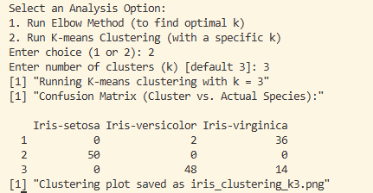
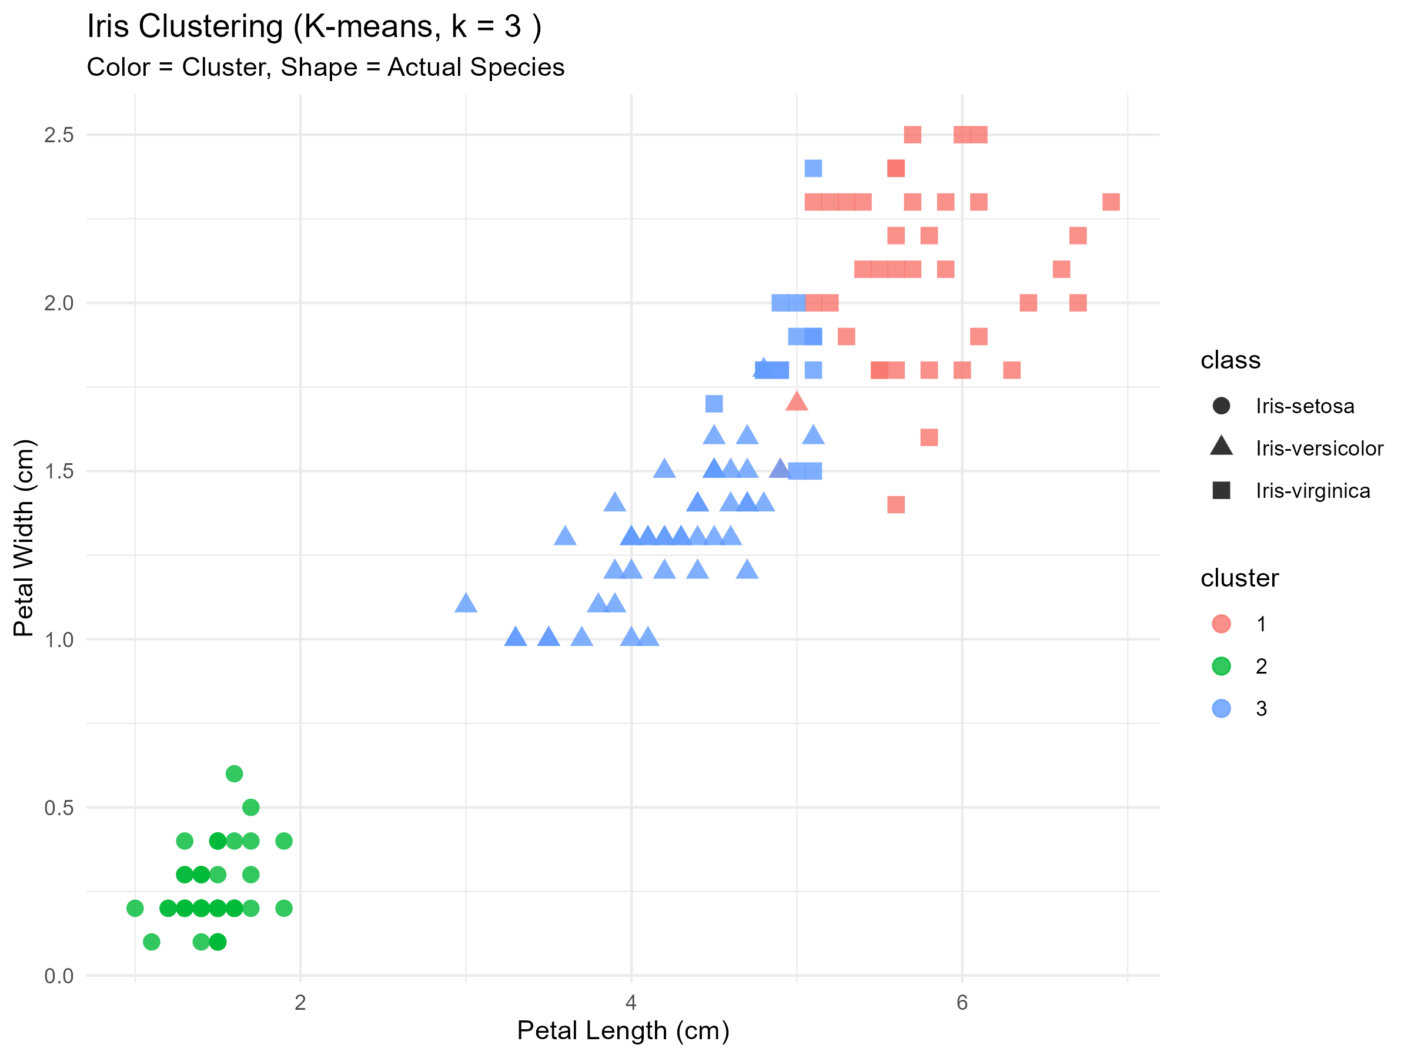
The separation of the clusters and their equivalent 3 classes remain similar visually, further reinforcing the optimal k obtained from the Elbow method.

Conclusion:
K-means clustering proves to be a useful tool for classifying unlabeled data so that needed optimization for any model we build can be done.

Appendix:
References:
- Duda, R.O., & Hart, P.E. (1973): "Pattern Classification and Scene Analysis". (A classic text on clustering theory).
- MacQueen, J. (1967): "Some methods for classification and analysis of multivariate observations". (The original paper for the K-means algorithm).
- Fisher, R.A. (1936): "The use of multiple measurements in taxonomic problems". (The original source of the Iris dataset).
AI Assistance Disclosure: Portions of the R code development and debugging for this project were assisted by Antigravity (Google DeepMind | Gemini 3.1 pro for initial architecture and flowchart build, Claude Opus 4.6 (Thinking) for code generation), an AI coding assistant, accessed via the Gemini IDE extension. The AI was used to help structure the codebase, generate helper functions and create visualization scripts. A portion of debugging was done by Codex (an OpenAI extension). All outputs were reviewed, validated, and approved by the author.

